Stroke – At least 50% of patients presenting with suspected stroke within first 4.5 hours of the time symptoms noted should have CT scan performed within 20 minutes of arrival.
Ischemic stroke
Up to 2 million brain cells die each minute during a stroke.
- Treatment with IV alteplase is considered Standard-of-Care when given to eligible patients in the first 4.5 hours from time of stroke onset. Please refer to your stroke protocol and consult with neurological expertise to determine eligibility.
- Treatment with mechanical thrombectomy is considered Standard-of-Care for patients with proximal large vessel occlusion (LVO) who are <6 hours from time of stroke onset. Initiate transfer as soon as high suspicion of LVO determined (clinical or imaging).
- Treatment with mechanical thrombectomy is considered Standard-of-Care for patients with proximal LVO who are 6-24 hours from last seen normal, if advanced imaging supports a favorable pattern. Consult with higher level of care with thrombectomy to determine if patient meets criteria for transfer.
Definitions:
- Last Seen Normal (LSN) may also be referred to as Last Known Well. LSN is the time the patient reports being in normal state or was last seen in normal state, if unable to provide history.
- Time Symptoms Noted (TSN) is the time the new symptoms/signs were first noted by patient or witness.
- If the patient was awake at the time of symptom onset or the stroke signs were witnessed, LSN = TSN = Time of Stroke Onset (TSO).
- If the patient is unable to provide onset time and the stroke signs were not witnessed, LSN is before TSN and TSO is unknown, but sometime between LSN and TSN.

A stroke code should be activated for all patients with ANY stroke symptom presenting <4.5 hours from the time symptoms were noted and for all VAN + patients presenting <24 hours from the time symptoms were noted. This should include patients who present <24 hours after being found or awakening with symptoms.
Stroke symptoms:
- Severe, unexplained headache
- Dizziness/Vertigo
- Visual loss
- Communication deficit
- facial or limb weakness or numbness
- Incoordination or disruption of gait
- Sudden loss of vision

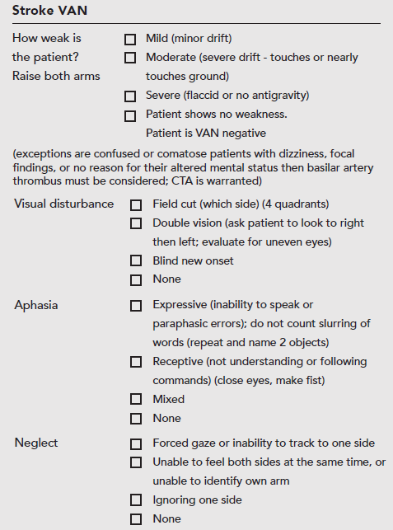
A patient is VAN positive if limb weakness is present
in addition to impairment in Vision, Aphasia, and/or Neglect.
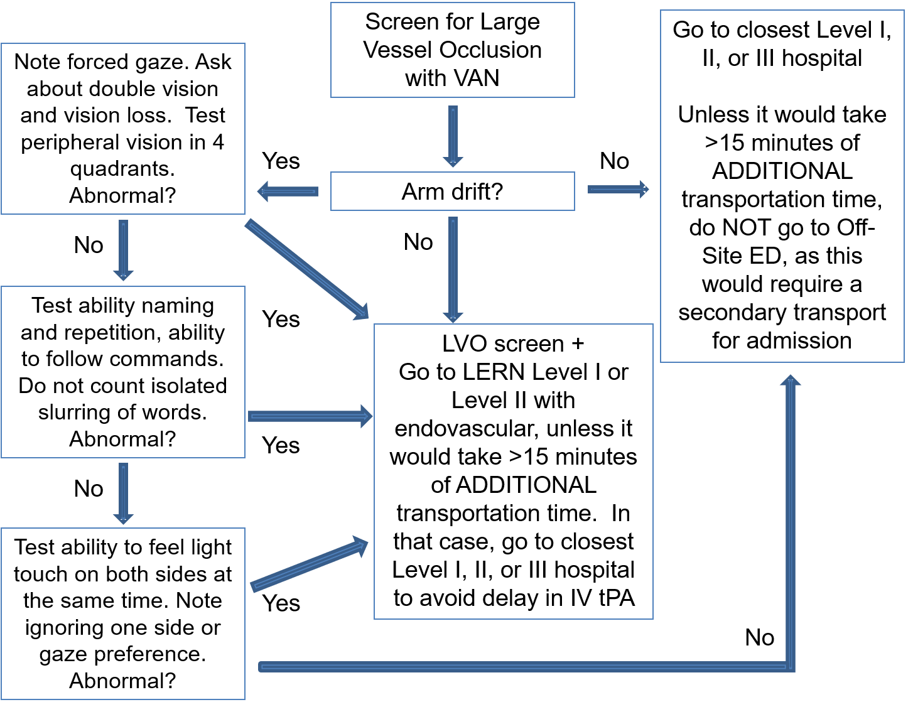
Screening algorithm for large vessel occlusion (LVO)
Consider basilar occlusion for sudden confusion with dizziness or focal neurological findings or sudden comatose state without cause; emergent CTA should be considered.

Stroke code
- Announce overhead alert and call the neurologist on call.
- Door-to-ED doc time target is ≤10 minutes. This is the time you document first seeing the patient.
- Door-to-neuro expertise time target is ≤15 minutes. This is the time documented that the neurologist has been made aware of the patient. Anyone (triage, clerk, nurse, mid-level, MD) can activate code stroke. Determine whose role it is to document the time the neurologist was reached.
- Door-to-CT performed is now ≤20 minutes. If the door-to-ED doc time target is met, there is no reason that door-to-CT performed target time should not be met.
- Door-to-CT interpreted is now ≤35 minutes. If the door-to-neuro expertise time target is met, the neurologist (if credentialed to interpret emergent neuroimaging) can provide and document a “real time” interpretation and should meet this target time.
- Door-to-labs resulted target time is now ≤35 minutes. The only lab mandatory to push tPA in a patient with no exposure to anticoagulation and no reason to suspect low platelets or coagulopathy is blood glucose (accucheck) based on AHA/ASA Guidelines for Emergency Management of the Patient with Acute Ischemic Stroke.
- Door-to-needle time target is now ≤45 minutes. If the door-to-needle time is > 45minutes, you MUST document the reason/s for the delay.

For patients with low NIHSS and/or perceived mild symptoms:
- Among patients presenting within 2 hours of stroke who were not treated with tPA due to mild or rapidly improving stroke symptoms, 28% could not ambulate without assistance at discharge and did not get discharged to home.
  - Even NIHSS = 0 stroke patients can be disabled; 16% could not ambulate without assistance at discharge and did not get discharged to home.
- While the PRISMS trial did not demonstrate benefit of alteplase over placebo, the trial excluded patients for any potentially disabling deficits.
- Disability is in the “eye of the beholder.”
  - Ask patients with perceived minor deficits if the symptoms/deficits, if persistent, would be disabling.
  - Test ability to walk and use both hands for two-handed tasks before deciding the patient has absence of disabling deficits.
  - Consider that a visual field cut may preclude driving.
- Alteplase/tPA has been proven to reduce the odds of disability. For patients with mild but disabling stroke symptoms, IV alteplase is indicated within 3 h from symptom onset of ischemic stroke.
- The risk of hemorrhage is about half that of patients treated in the NINDS randomized clinical trial of tPA for stroke. The risk of symptomatic ICH with worsening of NIHSS by at least 4 points was 1.3% in PRISMS.

From AHA/ASA Guidelines:
“There should be no exclusion for patients with mild but nonetheless disabling stroke symptoms, in the opinion of the treating physician, from treatment with IV alteplase because there is proven clinical benefit for those patients.† (Class I; LOE B-R)‡”

“Within 3 h from symptom onset, treatment of patients with mild ischemic stroke symptoms that are judged as nondisabling may be considered. Treatment risks should be weighed against possible benefits; however, more study is needed to further define the risk-to-benefit ratio.† (Class IIb; LOE C-LD)‡”

“For otherwise eligible patients with mild stroke presenting in the 3-to 4.5-hour window, treatment with IV alteplase may be reasonable. Treatment risks should be weighed against possible benefits.”

“For otherwise eligible patients with mild stroke presenting in the 3- to 4.5-h window, IV alteplase may be as effective as treatment in the 0- to 3-h window and may be a reasonable option. Treatment risks should be weighed against possible benefits. (Class IIb;LOE B-NR)‖”

Hemorrhagic stroke
CT scan should be performed within 20 minutes of arrival. CTA head should be considered to identify patients at risk of hematoma expansion and to evaluate for underlying vascular malformations; post contrast CT scan may identify a tumor. If patient is deteriorating, do NOT keep HOB flat for advanced imaging.
Determine severity with ICH Score:
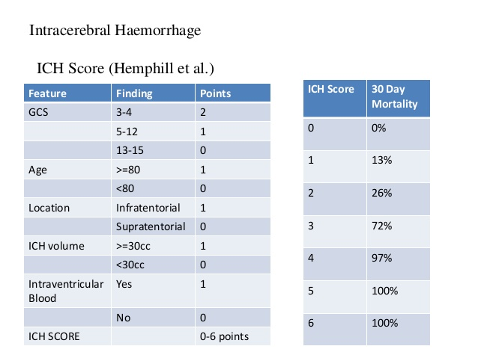
- Reverse coagulopathy when present based on coagulopathy reversal guidelines: (PCC or FFP with Vitamin K for Warfarin; Andexxa or PCC for Factor Xa inhibitor (Eliquis, Xarelto, Edoxoban); Praxbind or PCC for Pradaxa/dabigatran).

- Reduce SBP 120-140mmHg; if transferred, ensure BP has reached target before sending

- HOB elevated to 30 degrees; do not leave HOB flat for prolonged imaging or during transfer

- Prophylactic antiseizure medication is not recommended

- Consult with neurology and/or neurosurgery for determination of neurosurgical intervention

This page should be individualized for each center based on available resources.
Patients who can stay at xxxxx and do NOT require transfer (each site must edit based on capabilities):
- Any stroke patient as recommended by neurologist

- Most patients who are treated with IV tPA (excludes patients who are transferred for thrombectomy)

- Most ischemic stroke patients who are unlikely to require neurosurgical intervention due to brain edema.

- Intracerebral hemorrhage not meeting reason/s for transfer (see below).

- May consider monitoring a small traumatic SAH in patient with GCS 15 (vascular anomaly has been ruled out).
Patients who can cannot stay at XXX and should transfer:
- Subarachnoid hemorrhage. Should transfer to XXX using the Transfer Protocol.

- Intracerebral hemorrhage only if involving the cerebellum or with IVH/hydrocephalus or deemed by neurologist to be at high risk of developing hydrocephalus. These patients can transfer to xxxxx, based on the recommendation of neurologist.

- Ischemic stroke due to large vessel occlusion in the window for mechanical thrombectomy after consultation with neurologist. Should transfer to xxxxxx using the Transfer Protocol.

- Ischemic stroke in territory at high risk for requiring decompressive craniectomy.

