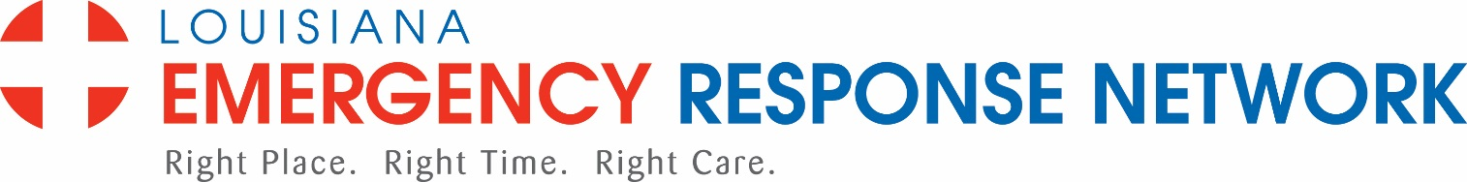

Region 8 – December 13, 2021
11:30 AM – 1:00 PM
In person – St. Francis Medical Center, Enaut Auditorium 408 Wood St., Monroe or via Zoom

- Welcome and Introductions O. Caskey

- Roll Call/Sign-in D. Spann

- Approval of Aug 9 and Oct. 11, 2021 minutes O. Caskey

- LERN Updates P. Hargrove
- Public Health S. Hutson

- Commission Member Updates – D. Spann
- Open: Cardiology/LSMS
- Dr. Jacqueline Bowers ratified as ACEP representative at the November Board meeting
- Nothing to report on Cardiology or LSMS
- New Officers to be seated in February

- Individual Commission Member Reports

- Injury Prevention
- Maternal Child Health Dickerson
- Sudden Impact, etc. Reichardt
- Stop the Bleed Spann
- Hwy. Traffic Safety Mitchell

- LCC Data D. Spann

- Education
- Burn Basics for EMS remains available
- Rural Trauma Team Development Course planning ongoing
- 12 Lead ECG available
- Grant planning ongoing with Living Well Foundation to provide Trauma Care After Resuscitation for the (2) Trauma programs locally

- Public Comment

- Next meeting— February 14, 2022

- Adjourn

