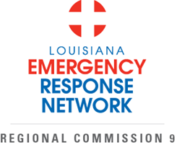
Our Mission: To defend the public health, safety, and welfare by protecting the people of the state of Louisiana from unnecessary deaths and morbidity due to trauma and time-sensitive illness.
Public members with a disability recognized by the American with Disabilities Act or a designated caregiver of such a person may participate in the LERN Region 9 Commission meeting by contacting (225) 756-3440
Lakeview Regional Medical Center
Magnolia Room
95 Judge Tanner Blvd
Covington, La 70433
June 1, 2025
10:00- 11:00

- Welcome and Introductions M. Duke

- Roll Call/Sign-in K. Peek

- Approval of April 1, 2025 Meeting Minutes M. Duke

- Commission Change: Service District Rep. M. Duke
Wayne Berkowitz, MD nominee
- HB 403 Y. Legendre

- Trauma Update M. Duke

- Burn M. Duke

- Stroke Update R. El Khoury

- STEMI Y. Legendre

- Education /injury prevention- Y. Legendre

- MCI – M. Duke

- Pt Routing Report/LERN Operations Y. Legendre

- Annual Report Y. Legendre

- Public Comment M. Duke

- Next meeting- 8/5 North Oaks M. Duke

- Adjournment M. Duke

